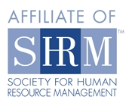
February 14, 2013 Meeting Notice
Flathead Valley Chapter of SHRM
(Society for Human Resource Management)

Date: Thursday, February 14, 2013
Time: 11:30 a.m. to 1:15 p.m. NOTE new meeting time: Our general meeting will start at 11:45 a.m.
Place: Hilton Garden Inn, 1840 US HWY 93 South, Kalispell – NOTE: OUR NEW LOCATION FOR MEETINGS
Lunch: As a member in good standing, your membership dues include the cost of lunch. Non-members are charged $12 per program and $12 if you wish to have lunch.

If you plan to attend, please RSVP by 12:00 p.m. NOON on Monday, February 11, 2013 to cindy.carpenter@nfs.stoneriver.com. We look forward to seeing you. Thank you.

Please advise if you wish to order lunch or not when you RSVP so we may provide the correct number to the Hilton.

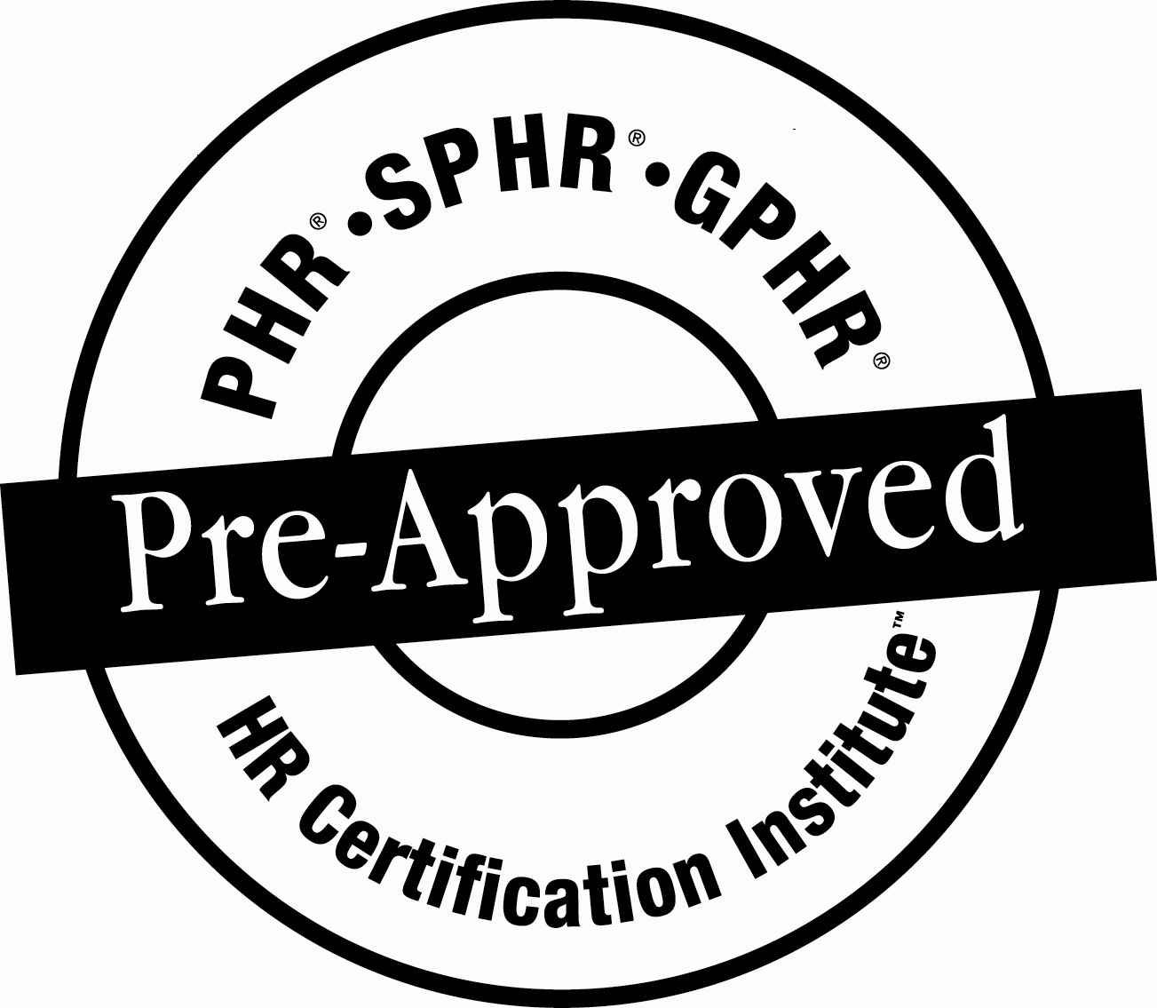

Program: Lean HR Practices: Our Role in Leading the Transformation
Ultimately, every organization deals with the challenge of overcoming operational inefficiencies, managing projects, and aligning systems and processes. Ignoring the value of establishing a lean culture can result in increased costs, decreased morale and limited organizational progress. The alternative is to understand the concept of Lean in a way that allows your organization to better stabilize processes and functions, build high functioning teams, and reduce unnecessary waste of your most valuable resource-your people. This is an interactive workshop which includes: 1)introduce concept of Lean; 2)explore why waste occurs and identify the value of continuous improvement; 3)discuss how to identify and gain understanding of your organization’s current state, workflows, behaviors and patterns; 4)explore common LEAN methods engaged in developing a culture of continuous improvement; 5)discuss HR’s role in leading the establishment, communication and transformation; 6)create a personal and organizational “Focus on Five” plan

Presenter: Colleen Rudio is the Chief Strategist and Business Consultant for Rudio Performance Management Group, LLC. In this role she reviews, designs and facilitates change management initiatives for clients. She founded this Group in 2009. She also serves as a Director of Corporate and Group Solutions for Western CPE, LLC. Previously, she was an Executive Vice President for a financial institution, Sr. Business Development Officer and Director of Marketing for a CPA firm and a Licensed Insurance Agent. She is a Board member and Past President of the Big Sky Chapter SHRM and an active volunteer in the community.

We encourage Flathead Valley Chapter members to bring guests to our monthly meetings to experience first hand, the benefit of SHRM. Members who bring guests will have an opportunity to win a lunch redeemable at a future meeting.

Support the SHRM Foundation and yourself — buy “Split the Pot” tickets! YOU could win money and/or lunch!
*The use of this seal is not an endorsement by the HR Certification Institute of the quality of the program. It means that this program has met the HR Certification Institute’s criteria to be pre-approved for recertification credit.
Visit our website at http://flatheadshrm.org
Join our LinkedIn group: http://www.linkedin.com/groups/SHRM-Flathead-Valley-Kalispell-Montana-4286381?trk=myg_ugrp_ovr.

